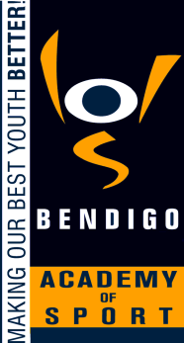
BENDIGO ACADEMY OF SPORT

ATHLETE PATHWAY TRAVEL GRANTS DISBURSEMENT

Rationale:
- Each year the Bendigo Academy of Sport applies for x2 Athlete Pathway Travel Grants through Sport Recreation Victoria. Each grant is to the value of $750 – one for male athletes and one for female athletes. All grants must be disbursed within government guidelines.

Aims:
- To improve opportunities for the Bendigo Academy of Sport athletes in relation to travel expenses incurred to participate at the elite level.

- To provide clarity in the disbursement of the grant funds in line with Victorian Government guidelines and procedures.

Implementation:
- Grants may be disbursed, subject to funds availability, to athletes as follows:
- National Representation
- Competing at a World Event
- Competing at a National Event
- The Executive Officer / Programs Manager shall identify athletes who meet the nomination criteria.
- The Programs Committee is to consider nominations for approval.

Evaluation:
- This policy will be reviewed as part of the BAS’s four year review cycle.

This policy was ratified by the Board of the Bendigo Academy of Sport in Feb 2016

