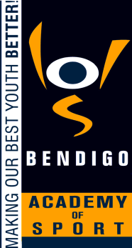
BENDIGO ACADEMY OF SPORT

UNIFORMS

Rationale:
A uniform dress code for all sports reinforces in athletes a pride in their own appearance, instills recognition of themselves as an integral part of the Bendigo Academy of Sport, promotes the sponsors of the Bendigo Academy of Sport and assists in developing pride in representing the Bendigo Academy of Sport

Aims:
- To further develop a sense of pride in, and identification with the Bendigo Academy of Sport.
- To maintain and enhance the positive image of the Bendigo Academy of Sport in the community.
- To promote equality amongst all athletes and sporting programs.
- To provide durable clothing that is cost effective and practical for the sporting environment.

Implementation:
- All items of uniform will have the Bendigo Academy of Sport logo and tracksuits will also have the logo of the naming rights sponsor of that particular sport.
- All athletes are expected to purchase the mandated items of clothing on the Uniform list; additional optional items may also be purchased.
- Uniform Orders are to be completed on the approved Uniform Order sheet and signed by a parent / guardian if the athlete is under 18 years of age.
- Families will be invoiced for all items ordered.
- Uniform items are not included in Program Cost Fees.
- All uniform items must be in the colors of the Bendigo Academy of Sport [navy / gold / white]
- The Board requires the Executive Officer through the program coaches to be responsible for the implementation of the Uniform policy
- No exemptions to the Uniform policy will be accepted
- Athletes will not be permitted to train unless they are in approved Bendigo Academy of Sport uniform
- All uniform proposals from individual sporting programs must be approved by the Executive Officer
- Uniform orders must be directed through the Executive Officer in line with Bendigo Academy of Sport purchase ordering procedures.
- All coaching staff will be provided with a Bendigo Academy of Sport uniform funded from the respective sport program budget.
- The expectation is that all coaching staff will set an example and be in approved Bendigo Academy of Sport apparel

This policy was ratified by the Board of the Bendigo Academy of Sport in November 2011

